Copyright reserved

Please turn over

**NATIONAL CERTIFICATE**

**APRIL EXAMINATION**

**STRENGTH OF MATERIALS AND STRUCTURES N5**

**6**

**APRIL 2016**

**This marking guideline consists of**

**7**

**pages.**



**MARKING GUIDELINE**

## QUESTION 1

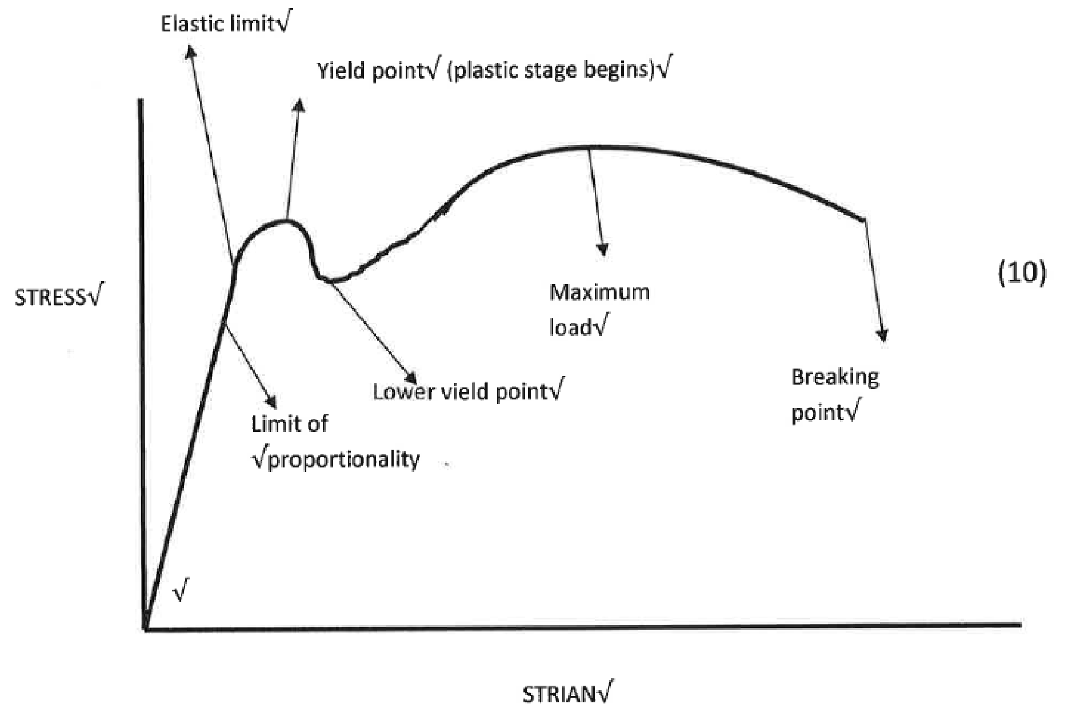

**[10]**

# **QUESTION 2**

2.1

(2)

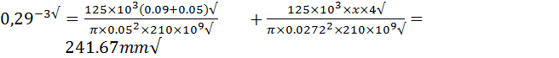2.2

(6)

2.3 





 (6)

2.4  (2)

**[16]**

## QUESTION 3

3.1

=

1

608

,

5

N.m

=

1455

,

91

N.m



The permissible torque is 1455.91N.m (5)

# 3.2

L

b

= 307

,

24

mm



# (6)

**[11]**

# **QUESTION 4**

4.1



(3)

4.2

= 118

,

14

kN.



(2)

4.3

=

59

,

69

kN



(2)

4.4

W

= 495

,

61

N



(5)

## [12] QUESTION 5

5.1

=

20

MPa(C)



(7)

5.2 Consider the external force

= 66.67

MPa



Resultant stresses



(8)

**[15]**

## QUESTION 6

= 6780.18

d

5

2

N/m

= 6199.439

N.m

= 12979.62

N.m

d = 201.3

mm

D = 211.4 mm



**[10]**

## QUESTION 7

7.1 Longitudinal stress



Circumferential stress

=

137.5 MPa



(4)

7.2

Axial load

= 388.772

kN



(2)

## [6]

T1560**(E)**(A6)T

## QUESTION 8

8.1 The least value of I

I =

= 8.575

mm

= 752.2

8

N



(4)

8.2



(2)

8.3 



(2)

## [8]

T1560**(E)**(A6)T

## QUESTION 9

150 x 2.11= 8.44XR

R = 37.5kN✓

8.44L= 150 x 6.33

L = 112.5 kN✓ (2)

✓

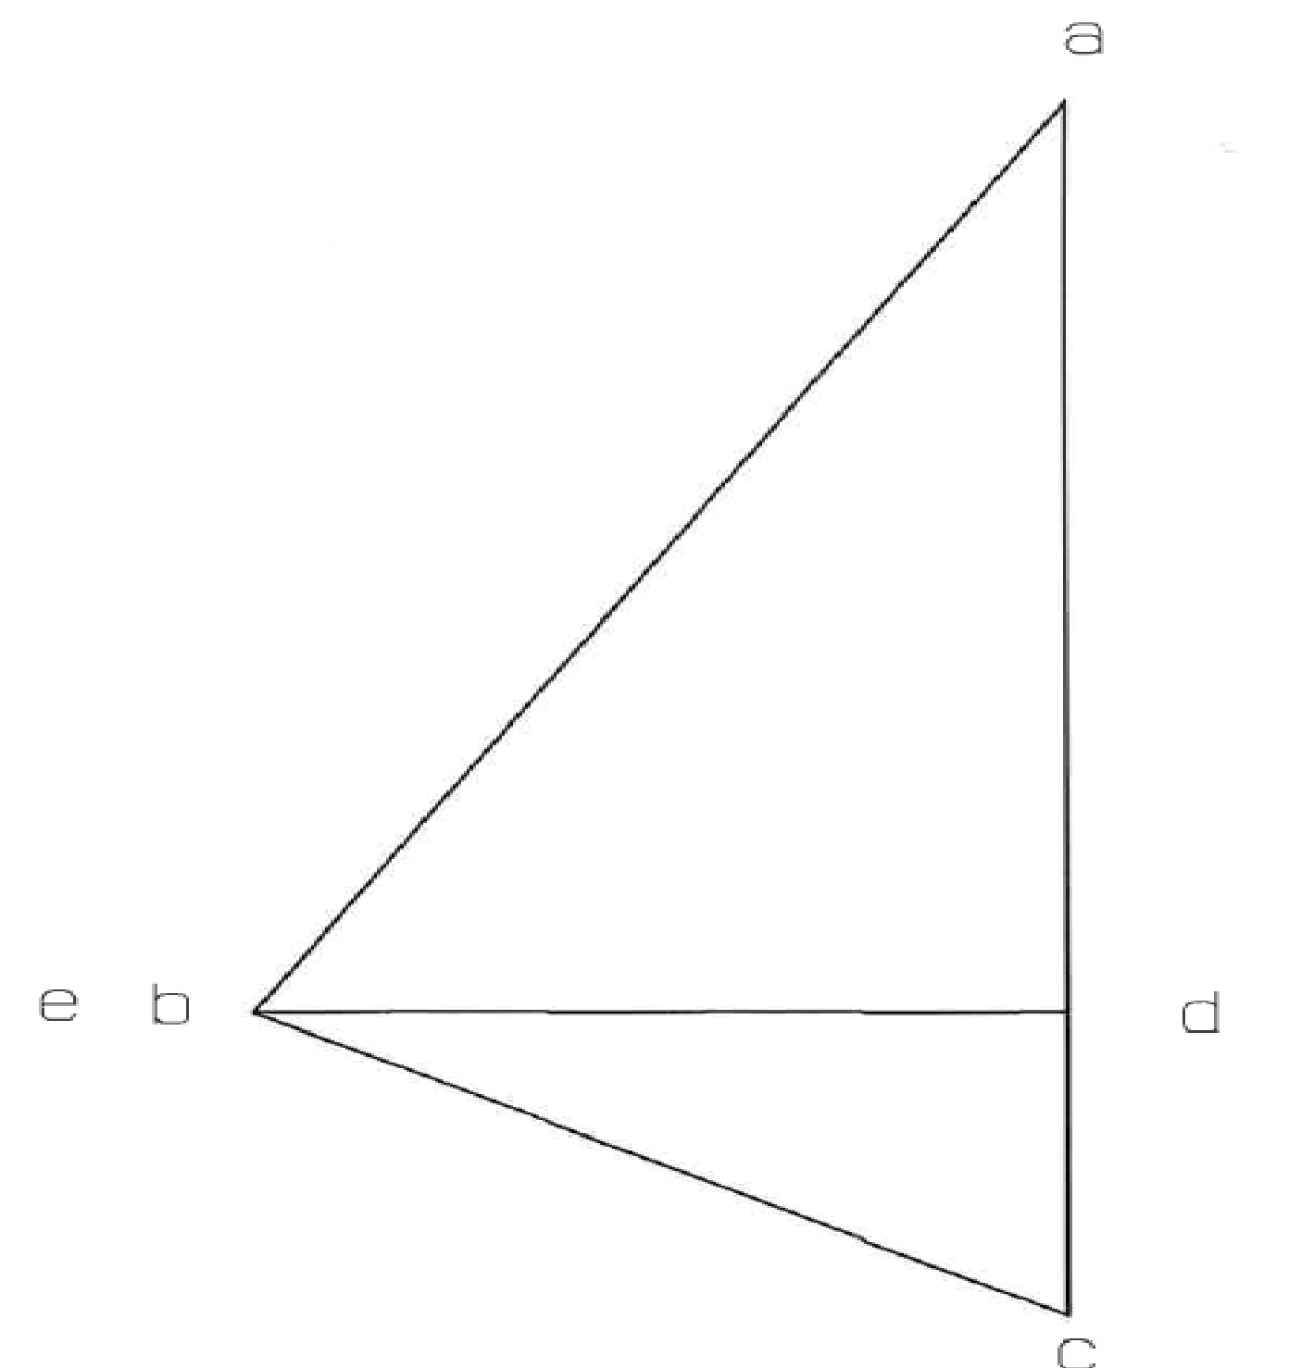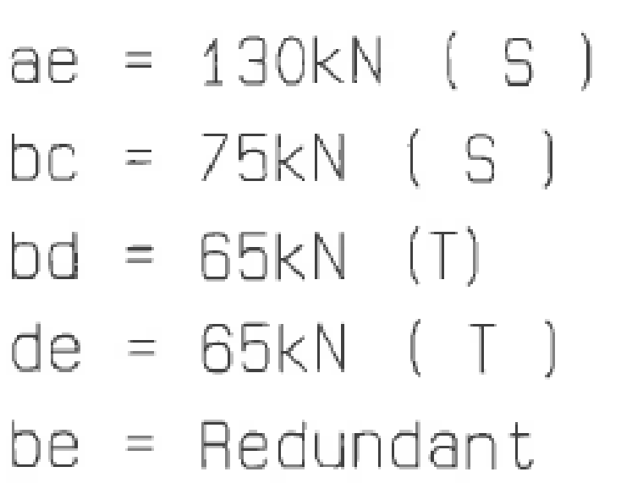

√√

√

√

√

√

√

√

√

√

✓

(5)

(5)

**[12]**

**TOTAL: 100**